Chapter 10 File I/O

- Stream: an object that enables the flow of data between a program and some I/O device or file
  - input stream: data flows into a program
    - System.in: connects to keyboard
Scanner keyboard = new Scanner(System.in);
  - output stream: data flows out of a program
    - System.out: connects to screen
System.out.println(Output stream“);
- Text Files(“ASCII files”): readable by human
- Binary Files: sequence of binary digits
  - more efficient than text files
- Writing to a Text File: class PrintWriter
  - stream class that can write to a text file
  - has print and println
  - need to import the followings:
import java.io.PrintWriter;
import java.io.FileOutputStream;
import java.io.FileNotFoundException;
  - PrintWrite has no constructor to take file name, so uses FileOutputStream to convert a file name to an object that can be used as the argument to PrintWriter constructor
  - for example
/* 1. Open file.
2. If file already exists, replace it.
3. If file doesn’t exist, create it.
4. nested constructor invocations on right hand side*/
PrintWriter outputStreamName = new PrintWriter(new
FileOutputStream(FileName));

  - close the stream when finish
    - outputStreamName.close();
    - release any resources used to connect the stream to the file
    - Java automatically closes it when program ends.
    - Programmer should explicitly close it.

  - streams are buffered
    - data is saved in a temporary location (buffer) instead of writing to the file ASAP
      - Because I/O devices are slow. 累積一定程度再一次輸出比較有效率
    - buffered data is written to file all at once, when
      - enough data accumulates
      - method flush is invoked: insuring all data is written to the file
- file name
  - suffix(.txt, .exe, ...) no meaning to Java program
  - every input file and output file used by program has two names
    - real file name (used by the operating system)
    - stream name (connected to the file)

- IOException
  - root class for input/output exceptions, e.g. FileNotFoundException
  - all are checked exceptions (must be caught)
- Unchecked Exception
  - not required to be caught
  - for example, NoSuchElementException, InputMismatchException, and IllegalStateException
- Appending to a Text File
  - syntax:
PrintWriter outputStreamName = new PrintWriter(new
FileOutputStream(FileName,true));
- toString helps with Text File Output
  - if a class has toString() method, it can be used as an argument to System.out.println directly
//no anObject.toString() required
outputStreamName.println(anObject)

- Reading from a text file: Scanner
  - syntax:
Scanner StreamObject = new Scanner(new
FileInputStream(FileName));
  - has nextInt and nextLine methods
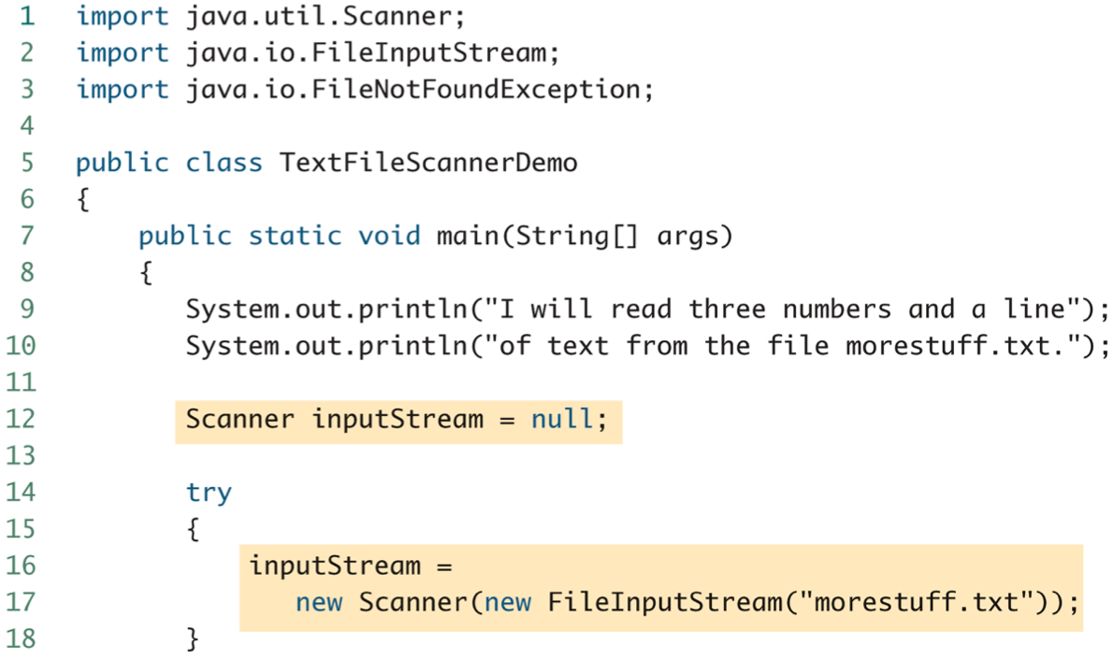
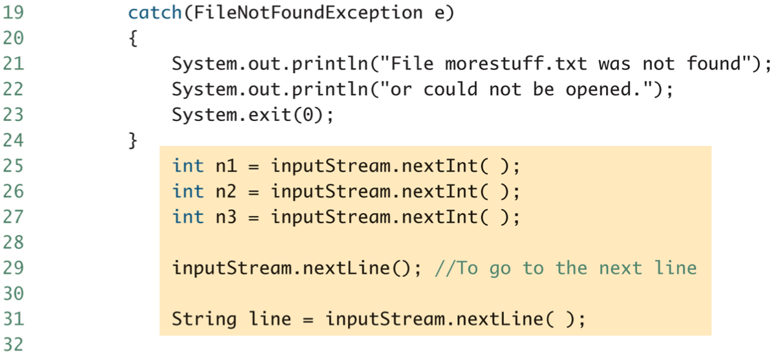
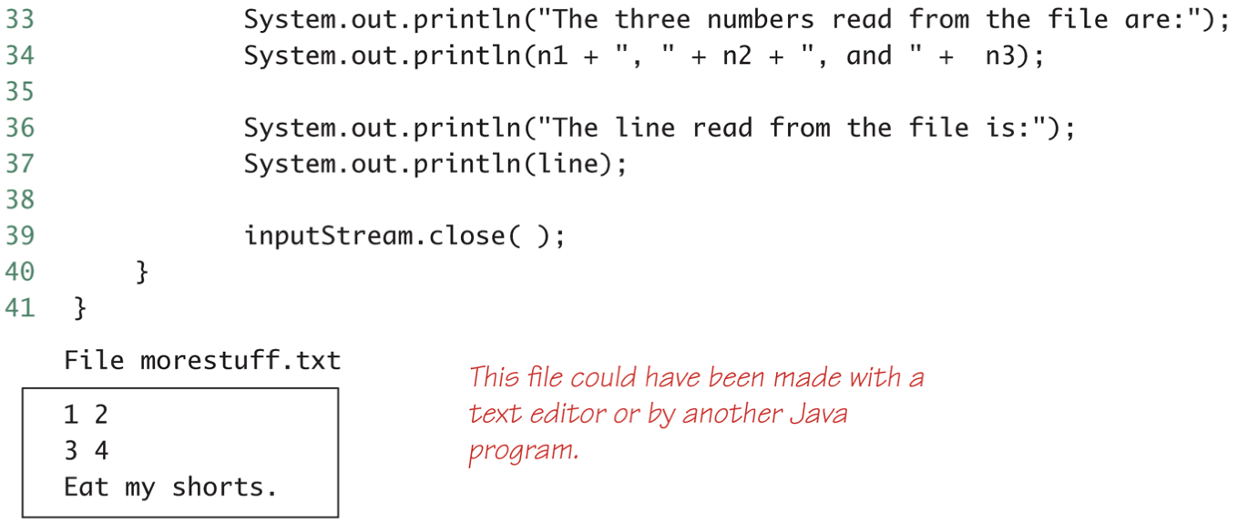
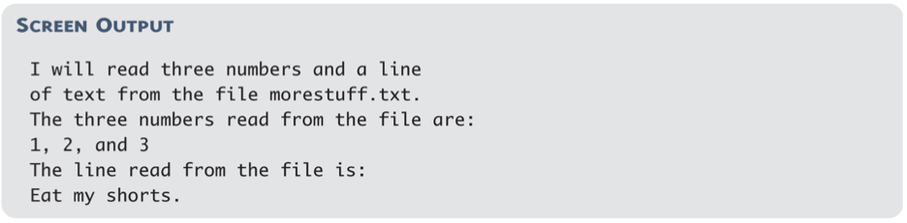

  - check end of text
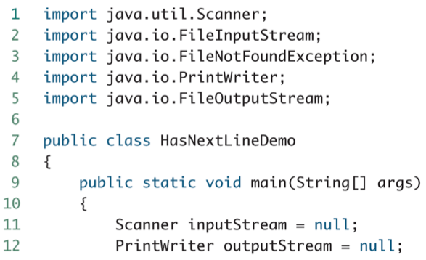
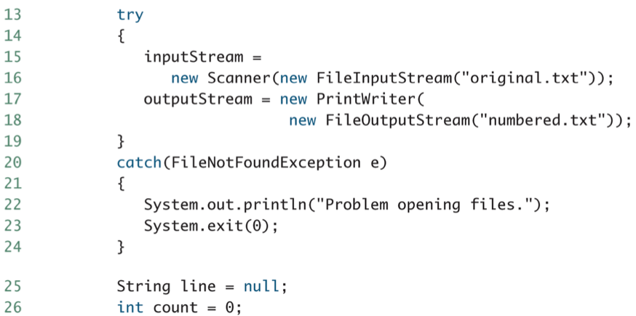
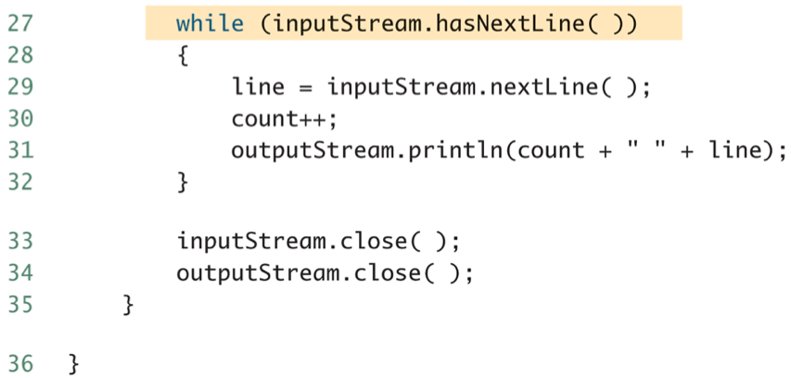
- Reading from a text file: BufferedReader
  - import java.io.BufferedReader;
import java.io.FileReader;
import java.io.FileNotFoundException;
import java.io.IOException;

  - has read and readLine method
    - read reads a single character, and returns type int.
      - Can use type cast:
char next = (char) (readerObject.read());
      - returns -1 when end of file
    - readLine returns null when end of file

  - BufferedReader readerObject = new BufferedReader(new
FileReader(FileName));
  - very similar to Scanner
  - can’t read a number from text
- Path Names: must be used when file not in the same directory
  - full path name
  - relative path name
- Class System
  - System.in
  - System.out: normal screen output
  - System.err: error messages to the screen
  - redirecting standard streams:
    - public static void setIn(InputStream inStream)
    - public static void setOut(PrintStream outStream)
    - public static void setErr(PrintStream outStream)
    - For example, instead of appearing on the screen, error messages could be redirected to a file. A new stream object should be created
    - Standard streams no need to be closed

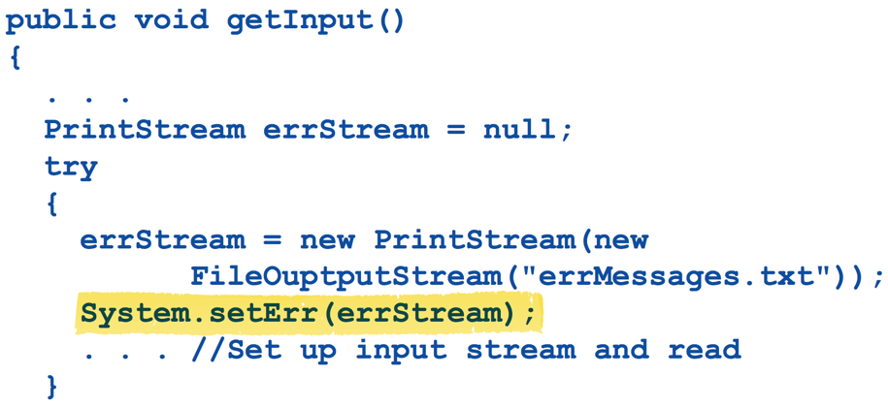
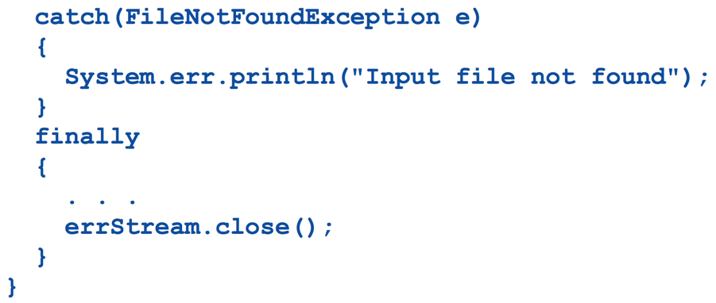

- File class
  - a wrapper class for file names
  - can be used to determined information information about the file
  - constructor and method examples
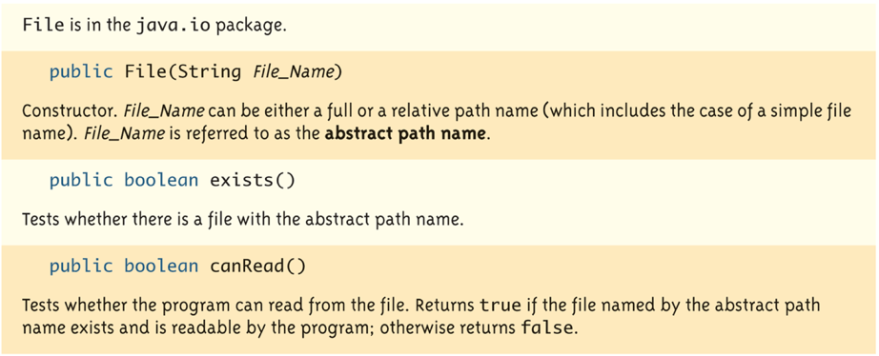
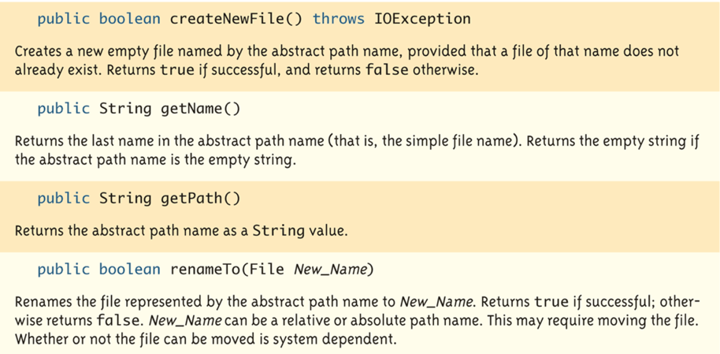

- Writing Simple Data to a Binary File: ObjectOutputStream
  - similar to PrintWriter class
- Random Access to Binary File: RandomAccessFile
  - for fast access in very large databases
  - read and write to the same file
  - has file pointer

